**Course Submission Cover Sheet  
Module:** CC6012 Data and Web Application **Deadline:** 3PM, xx of March 2024  
**Module Leader:** Dr Sandra Fernando

**Student ID:**

Acknowledgement

Table of Contents

Introduction 5

System Requirements 5

Database Generation 6

Database Design 6

Specification of database relations 6

Relational ER Diagram 6

Data Dictionary 7

Generation of Database – Using SQL Server 13

Data Models of the CW tables and generated table structures. 13

Input data into DB tables (INSERT) 16

Display data in the tables (SELECT) 21

Logical ER Diagram 24

Implementation of the Webbased Database Application 26

Testing 41

User manual 43

Further discussion 45

Table of Figure

Figure 1: Relational ER Diagram 6

Figure 2 : Insert Book Details 16

Figure 3 : Insert Guest Details 17

Figure 4 : Insert Book Issue Details 18

Figure 5 : Insert CD Details 19

Figure 6: Insert Admin Details 20

Figure 7 : Book Table 21

Figure 8 : Guest Details 21

Figure 9 : CD Table 22

Figure 10 Book Issue Table 22

Figure 11 : Admin Table 23

Figure 12 : Logical ER Diagram 24

Figure 13 : Home Page 25

Figure 14: Login Page 25

Figure 15: Login Page 1 26

Figure 16 : Login Successfully Page 26

Figure 17 : Guest Table 27

Figure 18 : Guest Add 27

Figure 19 : Guest Add 1 28

Figure 20 : Guest Add Successfully Page 28

Figure 21 : Edit Guest Page 29

Figure 22 : Guest Details Edit Successfully Page 29

Figure 23: Delete Student Page 30

Figure 24: Book Page 30

Figure 25: Add Book Details 31

Figure 26: Edit Book Details 32

Figure 27: Delete Book Details 33

Figure 28: CD Page 34

Figure 29 : Add CD Details 34

Figure 30: Edit CD Details 36

Figure 31: Delete CD Details 37

Figure 32 : Issue Book Page 37

Figure 33: New Book Issue Page 38

Figure 34: Search page 39

# Introduction

The Sydenham Library Management System is a comprehensive, webbased application designed to streamline the management of educational resources, including books and CDs. Developed for Sydenham Library, a mediumsized company specializing in providing educational materials to students across various subjects, this system is intended to enhance the efficiency and effectiveness of library operations. It facilitates seamless interactions between administrators and guests, ensuring a robust and userfriendly platform for managing library resources.

## System Requirements

The system is designed to meet the following requirements:

Home Page

* Company Information: Display essential information about Sydenham Library.
* SignIn Links: Provide signin links for administrators.

Admin Features

* SignIn: Secure login for administrators.
* Resource Management: Add, delete, edit, and update details of books and CDs.
* Issue and Return: Issue books to guests and update return information.
* Resource View: View all books and CDs available in the library.

Guest Features

* Search Books: Search for books based on various criteria.
* Reserve Books: Reserve books for future borrowing.
* Leave Messages: Leave messages for administrators or provide feedback.

# Database Generation

## Database Design

The database for the Sydenham Library Management System is structured to support the various functionalities of the application. The database design includes the following tables:

1. Book: Stores information about books, including reference number, title, ISBN, author, publication details, edition, published year, category, number of copies, and available copies.
2. Guest: Stores information about guests, including ID number, first name, last name, email, address, telephone number, registered date, and terminated date.
3. Book Issue: Records the issue and return details of books, linking book IDs with guest IDs and including issue and return dates.
4. CD: Stores information about CDs, including title, author, publication details, printed year, and category.
5. Admin : Stores administrator credentials for secure login.

## Specification of database relations

### Relational ER Diagram

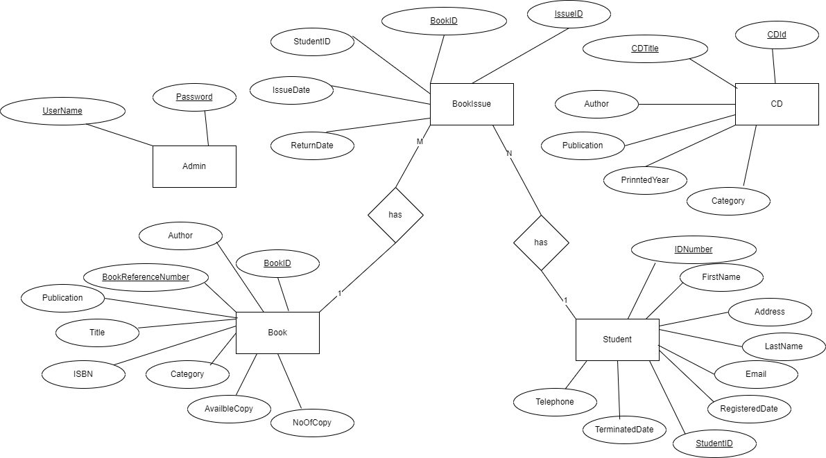

Figure 1: Relational ER Diagram

### Data Dictionary

**Book Table**

BOOK_ID

* Type: INT
* Constraints: Primary Key, Identity
* Description: Unique identifier for each book.

BOOK_REFERENCE_NUMBER

* Type: NVARCHAR(50)
* Constraints: Not Null
* Description: Unique reference number for the book.

TITLE

* Type: NVARCHAR(255)
* Constraints: Not Null
* Description: Title of the book.

ISBN

* Type: NVARCHAR(20)
* Constraints: Not Null, Unique
* Description: International Standard Book Number, unique to each book.

AUTHOR

* Type: NVARCHAR(255)
* Constraints: Not Null
* Description: Author of the book.

PUBLICATION

* Type: NVARCHAR(255)
* Constraints: Nullable
* Description: Publisher of the book.

EDITION

* Type: NVARCHAR(50)
* Constraints: Nullable
* Description: Edition of the book.

PUBLISHED_YEAR

* Type: INT
* Constraints: Nullable
* Description: Year the book was published.

CATEGORY

* Type: NVARCHAR(100)
* Constraints: Nullable
* Description: Category or genre of the book.

NO_OF_COPY

* Type: INT
* Constraints: Nullable
* Description: Total number of copies available in the library.

AVAILBLE_COPY

* Type: INT
* Constraints: Nullable
* Description: Number of copies currently available for borrowing.

**Guest Table**

GUEST_ID

* Type: INT
* Constraints: Primary Key, Identity
* Description: Unique identifier for each guest.

ID_NUMBER

* Type: NVARCHAR(15)
* Constraints: Not Null
* Description: Identification number of the guest.

FIRST_NAME

* Type: NVARCHAR(100)
* Constraints: Not Null
* Description: First name of the guest.

LAST_NAME

* Type: NVARCHAR(100)
* Constraints: Not Null
* Description: Last name of the guest.

EMAIL

* Type: NVARCHAR(255)
* Constraints: Not Null, Unique
* Description: Email address of the guest.

ADDRESS

* Type: NVARCHAR(255)
* Constraints: Nullable
* Description: Address of the guest.

TELEPHONE

* Type: NVARCHAR(20)
* Constraints: Nullable
* Description: Telephone number of the guest.

REGISTERED_DATE

* Type: DATE
* Constraints: Not Null
* Description: Date the guest registered with the library.

TERMINATED_DATE

* Type: DATE
* Constraints: Nullable
* Description: Date the guest's registration was terminated (if applicable).

**Book Issue Table**

ISSUE_ID

* Type: INT
* Constraints: Primary Key, Identity
* Description: Unique identifier for each book issue record.

BOOK_ID

* Type: INT
* Constraints: Not Null, Foreign Key (references LIBRARY_BOOK(BOOK_ID))
* Description: Identifier for the book being issued.

GUEST_ID

* Type: INT
* Constraints: Not Null, Foreign Key (references LIBRARY_GUEST(GUEST_ID))
* Description: Identifier for the guest to whom the book is issued.

ISSUE_DATE

* Type: DATE
* Constraints: Not Null
* Description: Date the book was issued.

RETURN_DATE

* Type: DATE
* Constraints: Not Null
* Description: Date the book is expected to be returned.

4. LIBRARY_CD

CD_ID

* Type: INT
* Constraints: Primary Key, Identity
* Description: Unique identifier for each CD.

CD_TITLE

* Type: NVARCHAR(255)
* Constraints: Not Null
* Description: Title of the CD.

AUTHOR

* Type: NVARCHAR(255)
* Constraints: Not Null
* Description: Author of the CD.

PUBLICATION

* Type: NVARCHAR(255)
* Constraints: Nullable
* Description: Publisher of the CD.

PRINTED_YEAR

* Type: INT
* Constraints: Nullable
* Description: Year the CD was released.

CATEGORY

* Type: NVARCHAR(100)
* Constraints: Nullable
* Description: Category or genre of the CD.

**Admin Table**

USER_ID

* Type: NVARCHAR(100)
* Constraints: Primary Key, Not Null
* Description: Unique identifier for each administrator, used for login.

PASSWORD

* Type: NVARCHAR(100)
* Constraints: Not Null
* Description: Password for the administrator's account, used for authentication.

This data dictionary provides a detailed description of each table's attributes and constraints, which is crucial for ensuring data integrity and supporting the functionality of the Sydenham Library Management System.

## Generation of Database – Using SQL Server

### Data Models of the CW tables and generated table structures.

CREATE DATABASE SYDENHAM_DB;

GO;

USE SYDENHAM_DB;

GO;

CREATE TABLE LIBRARY_BOOK

(

BOOK_ID INT PRIMARY KEY IDENTITY,

BOOK_REFERENCE_NUMBER NVARCHAR(50) NOT NULL,

TITLE NVARCHAR(255) NOT NULL,

ISBN NVARCHAR(20) NOT NULL UNIQUE,

AUTHOR NVARCHAR(255) NOT NULL,

PUBLICATION NVARCHAR(255),

EDITION NVARCHAR(50),

PUBLISHED_YEAR INT,

CATEGORY NVARCHAR(100),

NO_OF_COPY INT,

AVAILBLE_COPY INT

);

CREATE TABLE LIBRARY_GUEST (

GUEST_ID INT PRIMARY KEY IDENTITY,

ID_NUMBER NVARCHAR(15) NOT NULL,

FIRST_NAME NVARCHAR(100) NOT NULL,

LAST_NAME NVARCHAR(100) NOT NULL,

EMAIL NVARCHAR(255) NOT NULL UNIQUE,

ADDRESS NVARCHAR(255),

TELEPHONE NVARCHAR(20),

REGISTERED_DATE DATE NOT NULL,

TERMINATED_DATE DATE

);

CREATE TABLE LIBRARY_ISSUE_BOOKS (

ISSUE_ID INT PRIMARY KEY IDENTITY,

BOOK_ID INT NOT NULL,

GUEST_ID INT NOT NULL,

ISSUE_DATE DATE NOT NULL,

RETURN_DATE DATE NOT NULL,

FOREIGN KEY (BOOK_ID) REFERENCES LIBRARY_BOOK(BOOK_ID),

FOREIGN KEY (GUEST_ID) REFERENCES LIBRARY_GUEST(GUEST_ID)

);

CREATE TABLE LIBRARY_CD

(

CD_ID INT PRIMARY KEY IDENTITY,

CD_TITLE NVARCHAR(255) NOT NULL,

AUTHOR NVARCHAR(255) NOT NULL,

PUBLICATION NVARCHAR(255),

PRINTED_YEAR INT,

CATEGORY NVARCHAR(100)

);

CREATE TABLE LIBRARY_ADMIN

(

USER_ID NVARCHAR(100) PRIMARY KEY NOT NULL,

PASSWORD NVARCHAR(100) NOT NULL

);

### Input data into DB tables (INSERT)

LIBRARY_BOOK

INSERT INTO LIBRARY_BOOK (BOOK_REFERENCE_NUMBER, TITLE, ISBN, AUTHOR, PUBLICATION, EDITION, PUBLISHED_YEAR, CATEGORY, NO_OF_COPY, AVAILBLE_COPY)

VALUES

('BRN001', 'C# Programming', '978-3-16-148410-0', 'John Doe', 'Tech Books', '1st', 2021, 'Programming', 10, 8),

('BRN002', 'ASP.NET MVC', '978-0-12-345678-9', 'Jane Smith', 'Web Books', '2nd', 2020, 'Web Development', 5, 5),

('BRN003', 'Database Systems', '978-1-23-456789-0', 'Alan Turing', 'Data Books', '3rd', 2019, 'Databases', 7, 7),

('BRN004', 'Machine Learning', '978-4-56-123789-0', 'Andrew Ng', 'ML Books', '1st', 2022, 'Artificial Intelligence', 12, 10),

('BRN005', 'Python for Data Science', '978-5-67-891234-0', 'Guido van Rossum', 'Data Science Books', '4th', 2023, 'Programming', 15, 15);

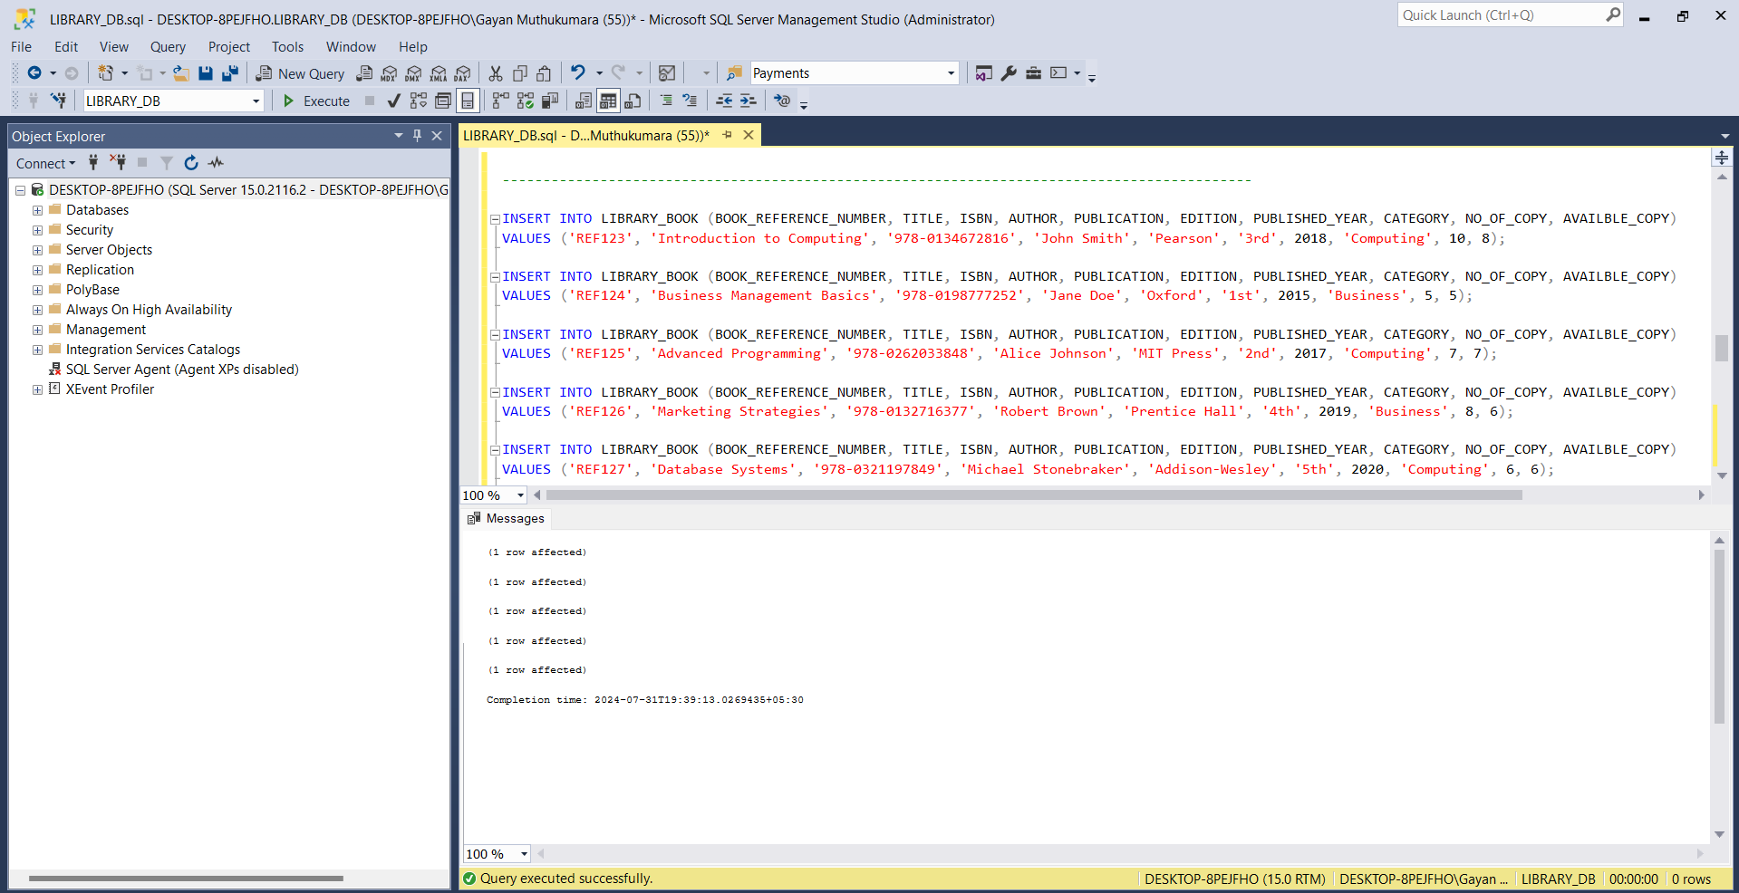

Figure 2 : Insert Book Details

LIBRARY_GUEST

INSERT INTO LIBRARY_GUEST (ID_NUMBER, FIRST_NAME, LAST_NAME, EMAIL, ADDRESS, TELEPHONE, REGISTERED_DATE, TERMINATED_DATE)

VALUES

('ID001', 'Alice', 'Johnson', 'alice.johnson@example.com', '123 Main St', '123-456-7890', '2023-01-15', NULL),

('ID002', 'Bob', 'Smith', 'bob.smith@example.com', '456 Oak St', '098-765-4321', '2023-02-20', NULL),

('ID003', 'Charlie', 'Brown', 'charlie.brown@example.com', '789 Pine St', '111-222-3333', '2023-03-10', NULL),

('ID004', 'David', 'Williams', 'david.williams@example.com', '101 Maple St', '444-555-6666', '2023-04-05', NULL),

('ID005', 'Eve', 'Davis', 'eve.davis@example.com', '202 Birch St', '777-888-9999', '2023-05-15', NULL);

Figure 3 : Insert Guest Details

LIBRARY_ISSUE_BOOKS

INSERT INTO LIBRARY_ISSUE_BOOKS (BOOK_ID, GUEST_ID, ISSUE_DATE, RETURN_DATE)

VALUES

(1, 1, '2023-06-01', '2023-06-15'),

(2, 2, '2023-06-10', '2023-06-25'),

(3, 3, '2023-06-15', '2023-06-30'),

(4, 4, '2023-06-20', '2023-07-05'),

(5, 5, '2023-06-25', '2023-07-10');

Figure 4 : Insert Book Issue Details

LIBRARY_CD

INSERT INTO LIBRARY_CD (CD_TITLE, AUTHOR, PUBLICATION, PRINTED_YEAR, CATEGORY)

VALUES

('Learning C#', 'John Doe', 'Tech Media', 2021, 'Programming'),

('Mastering ASP.NET', 'Jane Smith', 'Web Media', 2020, 'Web Development'),

('Database Essentials', 'Alan Turing', 'Data Media', 2019, 'Databases'),

('AI Fundamentals', 'Andrew Ng', 'AI Media', 2022, 'Artificial Intelligence'),

Figure 5 : Insert CD Details

LIBRARY_ADMIN

INSERT INTO LIBRARY_ADMIN (USER_ID, PASSWORD) VALUES ('Admin','Admin@$123')

Figure 6: Insert Admin Details

### Display data in the tables (SELECT)

SELECT * FROM LIBRARY_BOOK

Figure 7 : Book Table

SELECT * FROM LIBRARY_GUEST

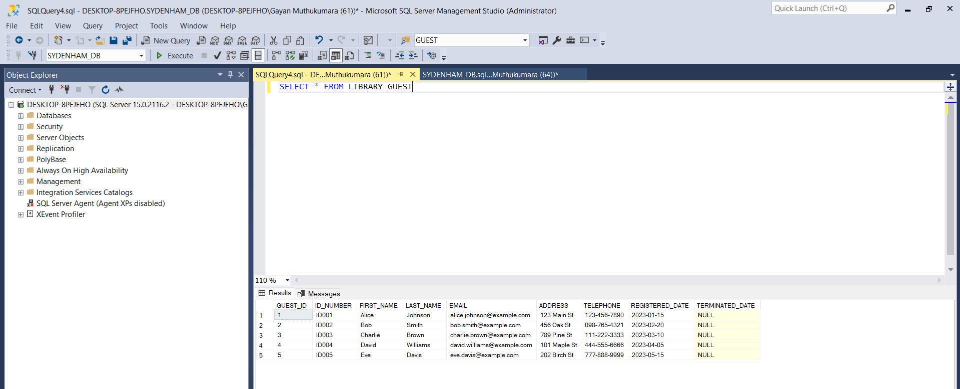

Figure 8 : Guest Details

SELECT * FROM LIBRARY_CD

SELECT * FROM LIBRARY_ISSUE_BOOKS

Figure 9 : CD Table

Figure 10 Book Issue Table

SELECT * FROM LIBRARY_ADMIN

Figure 11 : Admin Table

### Logical ER Diagram

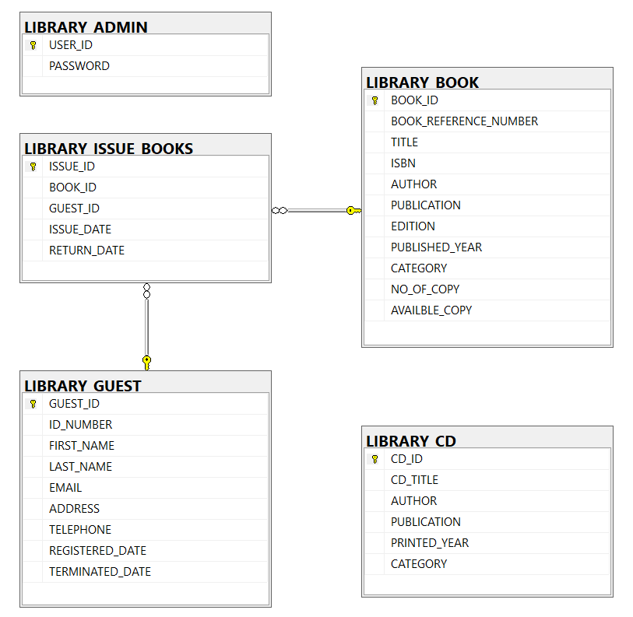

Figure 12 : Logical ER Diagram

# Implementation of the Webbased Database Application

Home Page

Figure 13 : Home Page

Login Page

Figure 14: Login Page

Figure 15: Login Page 1

Figure 16 : Login Successfully Page

Guest Page

Figure 17 : Guest Table

Add New Guest

Figure 18 : Guest Add

Figure 19 : Guest Add 1

Figure 20 : Guest Add Successfully Page

Edit Guest

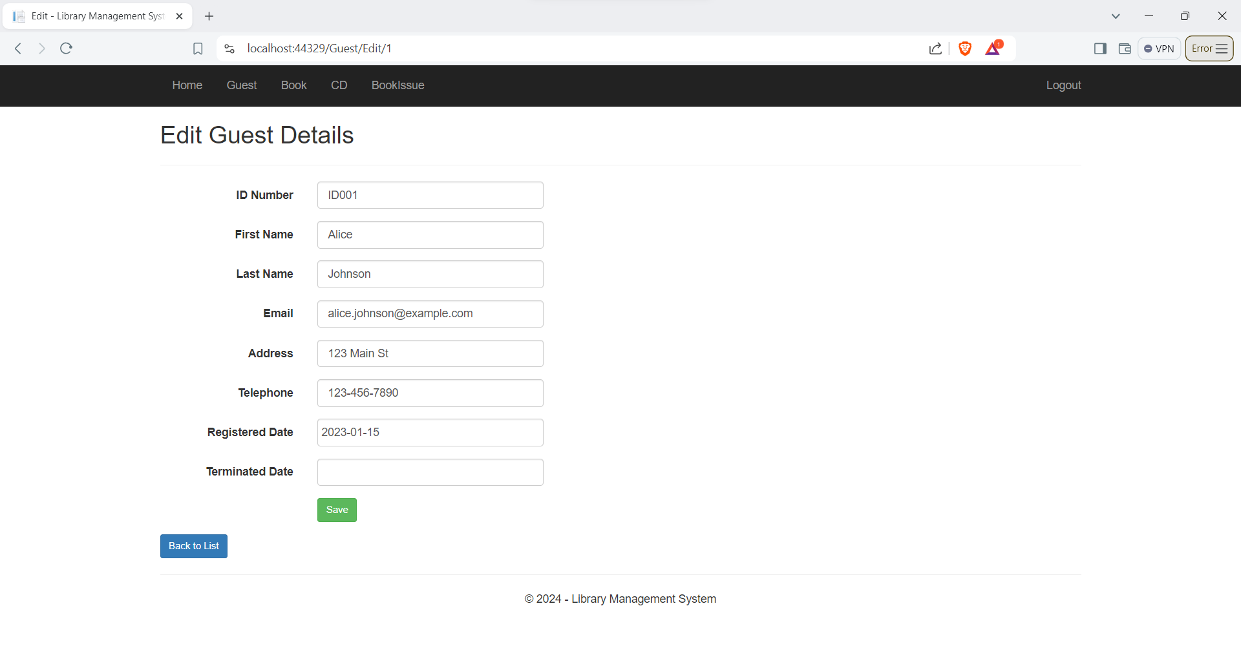

Figure 21 : Edit Guest Page

Figure 22 : Guest Details Edit Successfully Page

Delete Guest Details

Figure 23: Delete Student Page

Book Page

Figure 24: Book Page

Add Book

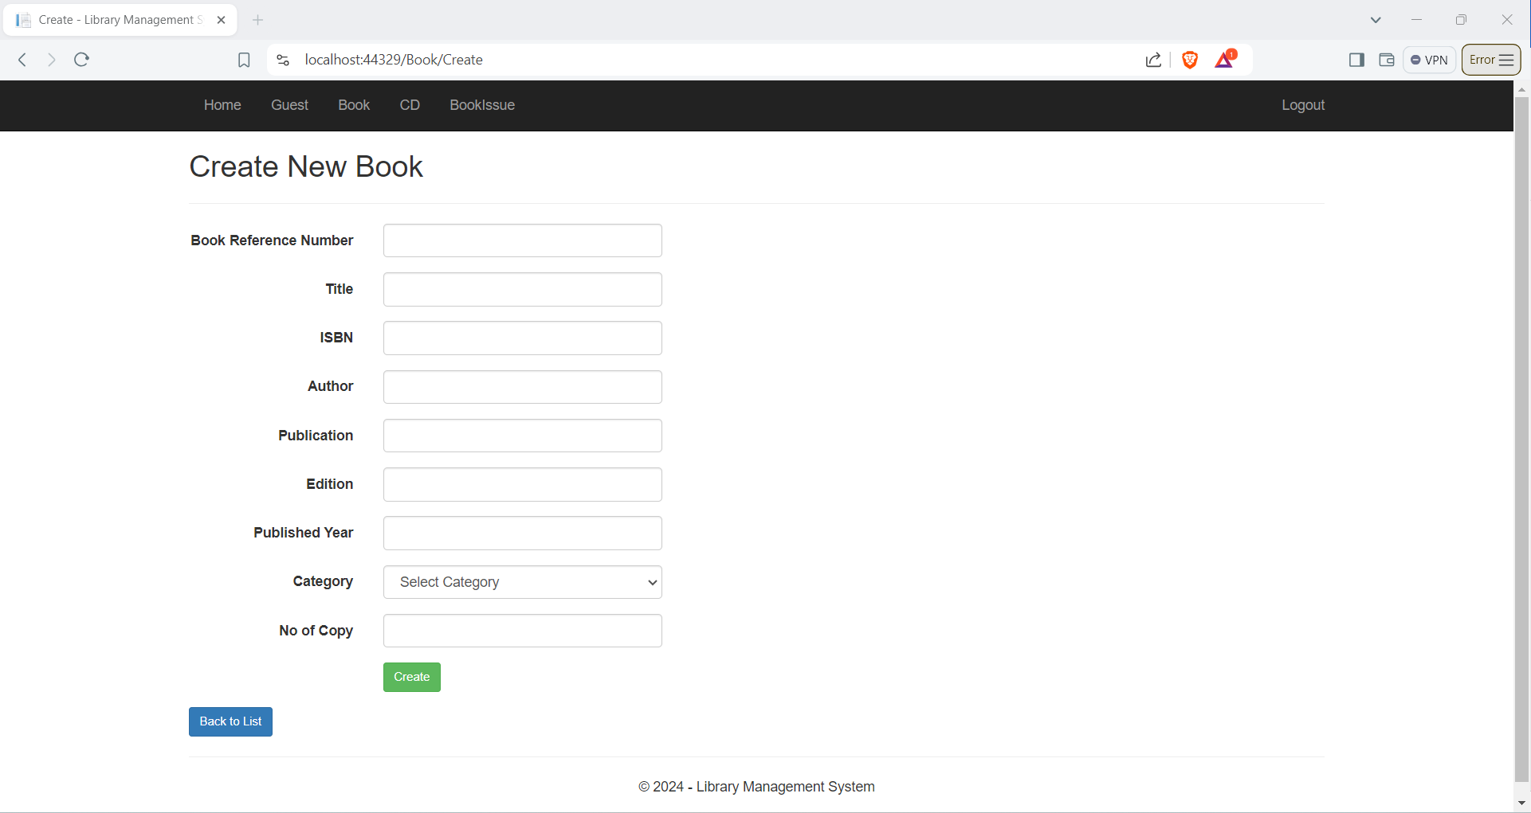

Figure 25: Add Book Details

Edit Book

Figure 26: Edit Book Details

Delete Book

Figure 27: Delete Book Details

CD Page

Figure 28: CD Page

Add CD

Figure 29 : Add CD Details

Edit CD

Figure 30: Edit CD Details

Delete CD

Figure 31: Delete CD Details

Book Issue Page

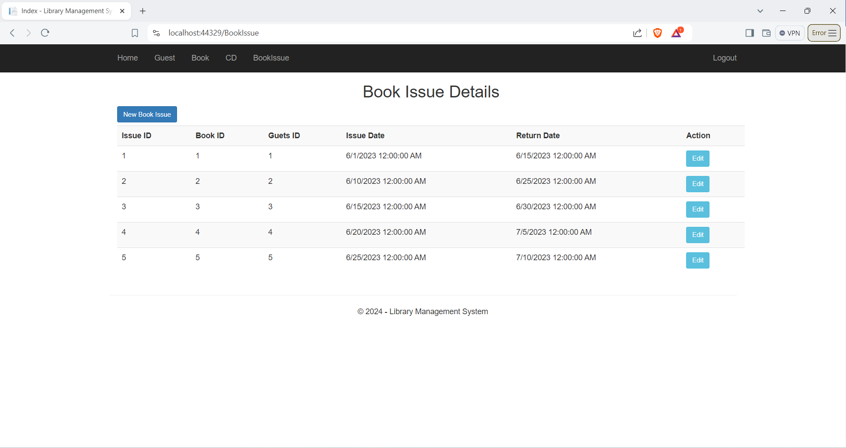

Figure 32 : Issue Book Page

New Book Issue

Figure 33: New Book Issue Page

Search Book Page

Figure 34: Search page

# Testing

|  |  |  |  |  |  |
| --- | --- | --- | --- | --- | --- |
| Test Case ID | Test Objective | Preconditions | Test Steps | Expected Result | Pass / Fail |
| 1.1 | Verify Home Page Display | None | 1. Open the web browser.  2. Navigate to the home page URL. | The home page should display the company information and sign-in links for the admin. | Pass |
| 2.1 | Admin Sign-In | Admin credentials exist in the database. | 1. Navigate to the admin sign-in page.  2. Enter valid admin credentials.  3. Click the "Sign In" button. | Admin should be signed in and redirected to the admin dashboard. | Pass |
| 2.2 | Add Book | Admin is signed in. | 1. Navigate to the add book page.  2. Enter book details.  3. Click the "Add Book" button. | The book should be added to the library, and a success message should be displayed. | Pass |
| 2.3 | Delete Book | Admin is signed in, and at least one book exists in the library. | 1. Navigate to the book list page.  2. Select a book to delete.  3. Click the "Delete" button. | The selected book should be deleted from the library, and a success message should be displayed. | Pass |
| 2.4 | Update Book Details | Admin is signed in, and at least one book exists in the library. | 1. Navigate to the book list page.  2. Select a book to update. 3. Modify the book details.  4. Click the "Update" button. | The book details should be updated, and a success message should be displayed. | Pass |
| 2.5 | Issue Book | Admin is signed in, a book exists, and a guest exists. | 1. Navigate to the issue book page.  2. Select a book and a guest. 3. Enter the issue date and return date.  4. Click the "Issue Book" button. | The book should be issued to the guest, and a success message should be displayed. | Pass |
| 2.6 | View All Books and CDs | |  | | --- | | Admin is signed in. |  |  | | --- | |  | | 1. Navigate to the book list page.  2. Navigate to the CD list page. | All books and CDs should be listed. | Pass |
| 3.1 | Search Book | At least one book exists in the library. | 1. Navigate to the search page.  2. Enter search criteria.  3. Click the "Search" button. | The search results should display books that match the criteria. | Pass |
| 3.2 | Validate Book Entry in Database | A new book has been added. | 1. Query the LIBRARY_BOOK table.  2. Check the details of the newly added book. | The book details should match the input data. | Pass |
| 3.3 | Validate Guest Entry in Database | A new guest has been registered. | 1. Query the LIBRARY_GUEST table.  2. Check the details of the newly registered guest. | The guest details should match the input data. | Pass |
| 4.1 | Validate Issue Book Entry in Database | A book has been issued to a guest. | 1. Query the LIBRARY_ISSUE_BOOKS table.  2. Check the details of the newly issued book record. | The issue details should match the input data. | Pass |

# User manual

**Admin Login**

Step 1: Admin needs to visit the login page

Step 2: Admin needs to click the “Login” tab in the header

Step 3:Admin need to enter the already given username and password in the Login form.

**Adding a Guest to the System**

**Step 1:** Click the "Guest" tab in the header.  
**Step 2:** Click the "Add New Guest" button at the top left corner of the guest details table.  
**Step 3:** Fill in the new guest's details in the provided form.  
**Step 4:** Click the "Save" button to save the guest's details.

**Editing and Deleting an Existing Guest's Details**

**Step 1:** Go to the "Guest" page.  
**Step 2:** In the "Action" column of the relevant guest, click the "Edit" button.  
**Step 3:** Edit the guest's details in the form.  
**Step 4:** Click the "Save" button to update the details.  
**Step 5:** To delete a guest's details, click the "Delete" button in the "Action" column.

**Adding New Book Details**

**Step 1:** Click the "Book" tab in the header.  
**Step 2:** Click the "Add New Book" button at the top left corner of the book details table.  
**Step 3:** Fill in the new book's details in the provided form.  
**Step 4:** Click the "Save" button to save the book's details.

**Editing and Deleting an Existing Book's Details**

**Step 1:** Go to the "Book" page.  
**Step 2:** In the "Action" column of the relevant book, click the "Edit" button.  
**Step 3:** Edit the book's details in the form.  
**Step 4:** Click the "Save" button to update the details.  
**Step 5:** To delete a book's details, click the "Delete" button in the "Action" column.

**Adding a CD to the System**

**Step 1:** Click the "CD" tab in the header.  
**Step 2:** Click the "Add New CD" button at the top left corner of the CD details table.  
**Step 3:** Fill in the new CD's details in the provided form.  
**Step 4:** Click the "Save" button to save the CD's details.

**Editing and Deleting an Existing CD's Details**

**Step 1:** Go to the "CD" page.  
**Step 2:** In the "Action" column of the relevant CD, click the "Edit" button.  
**Step 3:** Edit the CD's details in the form.  
**Step 4:** Click the "Save" button to update the details.  
**Step 5:** To delete a CD's details, click the "Delete" button in the "Action" column.

**Issuing a Book**

**Step 1:** Click the "IssueBook" tab in the header.  
**Step 2:** Click the "Issue Book" button at the top left corner of the book issue details table.  
**Step 3:** Fill in the book issuing details in the form, selecting the book and guest names from the dropdown lists.  
**Step 4:** Click the "Submit" button to save the book issuing details.

**Searching for a Book**

**Step 1:** On the welcome page, locate the "Search Book" header.  
**Step 2:** Click on the "Search Book" header to open the search filter form.

# Further discussion

The development of the Library Management System for Sydenham Library began with a comprehensive planning phase. During this phase, extensive discussions with stakeholders were held to clearly understand the project’s scope and requirements. This led to the design of a detailed database schema, which included tables for books, students, issued books, CDs, and admin users. Foreign key constraints were meticulously implemented to maintain the relationships between these tables, demonstrating a thorough grasp of SQL and relational database principles.

Following the planning phase, the implementation of Create, Read, Update, and Delete (CRUD) operations for various entities within the system commenced. This involved writing robust SQL queries and stored procedures, which are essential for the database interactions. Concurrently, the development of the data access layer in the application code was undertaken using ADO.NET. This layer was responsible for handling database connections, executing commands, and reading data, forming a crucial bridge between the application and the database.

Collaboration with frontend developers was integral during the database design phase to ensure that the backend schema aligned with the user interface requirements. Throughout the development process, rigorous testing and debugging were conducted to ensure the system’s reliability and performance. This included unit testing of individual components, integration testing to ensure that different parts of the system worked together seamlessly, and user acceptance testing to collect feedback from stakeholders.

Debugging, particularly of issues related to database transactions and data integrity, provided valuable hands-on experience in troubleshooting and resolving complex issues. These efforts ensured that the system was robust, reliable, and error-free, ready to meet the needs of Sydenham Library effectively.